Testing report - MediaRekt

MediaRekt is a service that allows it’s users to view, upload and edit images, audio and video. Its mobile based, but it can be accessed and used with any device that has an internet browser. The target groups are males and females between ages 15-25, the users like to upload media and share it with their friends. They also like to spend time viewing, rating and commenting on what other users have uploaded. The service will be used with the user’s device anywhere where there is an internet connection.

Three users tested MediaRekt service, Kai and Raine both from the mediatekniikka major and Joni from the software development major. The testers were given a link that they could use to access a MediaRekt version which was uploaded to the Metropolia FTP (<http://users.metropolia.fi/~anttijva/mediarektservice/src/app.html>). All of the users used the service on their own smartphones.

We used the “Thinking aloud” method, which means that Matti asked the testers questions like “How do you like the upload modal?” or “What do you think about the image editing functionalities?”. From the beginning we told the users what they were expected to test and helped with any possible errors they might come across.

The test scope was slightly expanded from the original test plan, as we managed to put more functionality in place.  All of the users tested the following functions:

1. Browsing images
2. Registering a user
3. Logging in
4. Uploading an image
5. Sharing an image
6. Editing an image
7. Searching for images

As a result from testers “thinking aloud” we were able to take note of multiple defects in the service. The testers also pointed out that for example the infinite scrolling functionality that we were thinking of implementing was not actually preferred, instead the testers wanted to have control on when new content is loaded. The following defects were pointed out to us during the testing:

* 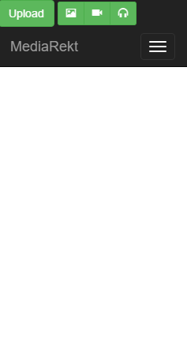Password is not hidden when logging in or creating a new account
* Modals don’t close after e.g. logging in
* User has to zoom to be able to click the image editing buttons
* No feedback for registering or uploading an image
* Service doesn’t look good on landscape
* Content is not visible when first accessing the site
* Not clear how to use the site at first (user needs to select what to view from the navbar)
* Image editing canvas is distracting

Figure No content visible when first accessing site

* Buttons in login screen should be other way around
* Home page button doesn’t work

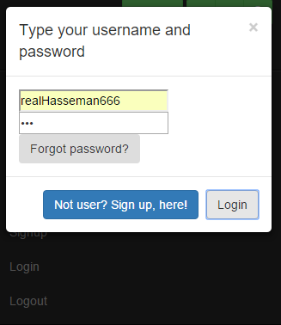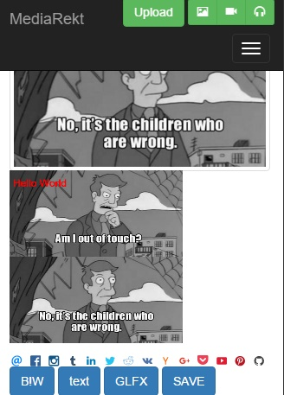

Figure The modal doesn't close after logging in. The login / sign up buttons should be other way around.

Figure The editing buttons are hard to click. The editing canvas is in a bad place, should be hidden. MediaRekt buttong doesn’t work

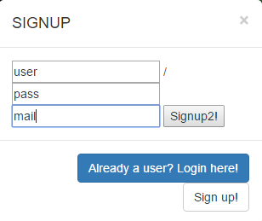

Figure . The password is not hidden when registering. There is no feedback after registering or logging in.

All of the defects were found by the testers when they were using the service on their own smartphones, two of the testers used the site on portrait mode and one tried to use it in landscape mode. The testers let us know of the defects or the defects came up when we were asking them questions. These defects were then written down on the test results file.

We will continue adding more functionality to the service while also fixing the defects. Some of the defects listed have already been fixed.

Link to test notes: https://docs.google.com/document/d/1IVbvDkGvvygdtiiN1dH7yAz1eoAArwlIv0CqRc0u5_0/edit?usp=sharing